



**DATA VISUALIZATION:  
DVT PROJECT**

**Pooja Kabadi**

**PGP-DSBA Online**

**Batch- A4**

**17-04-2021**

# Problem Statement:

Consider that you are a Lead Data Analyst at an Insurance Claims company that has provided you with the Car Insurance Claims dataset. You have been given a task to explore the data, create different plots and interpret useful insights/findings. Your end goal here will be to create a storyboard that you have to present to the Senior Management and the story has to have an end objective and should follow a logical flow to display that you are heading towards achieving the end objective. This will help the Senior Management in taking some decisive actions on the current claims system in place. This storyboard will be an open-ended story for you to explore various different features in the data and try to showcase different plots. Make sure to have minimum clutter in the plots, follow a consistent color scheme across all the plots, and use proper colors to highlight a specific insight.

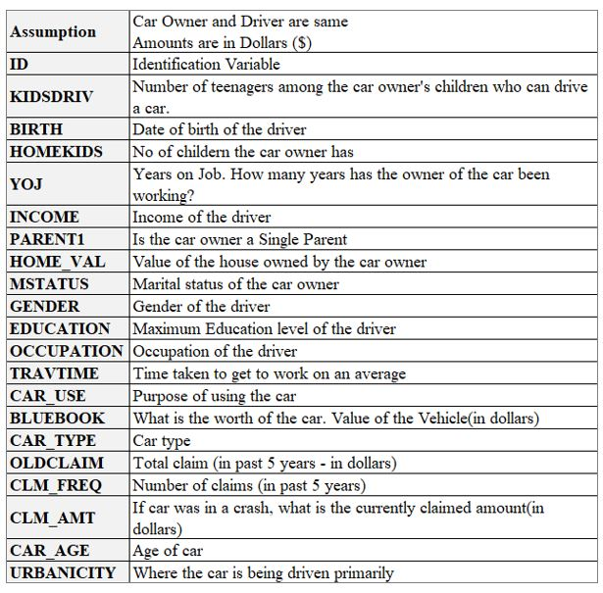**Data Dictionary:**

# Car Insurance Claim Story

Insurance companies/sales teams can use the story to analyse claims data across a variety of factors, resulting in trends and customer segmentation across diverse demographics. Inferences can be used to help the organisation build future insurance policies and launch strategies.

# Assumptions:

* The dataset includes a number of different variables. However, there may be additional aspects that are not taken into account.
* Dollars ($) are used as a unit of measurement for claim amount.
* The age of the car "-3" is regarded incorrect and is replaced with 3 as the age of the car cannot be negative.
* Assume there are no missing data in the dataset; otherwise, the analysis would be not useful.
* The number of years/age computed as of 2022 will be based on the YOJ and birth variables.
* The dashboard is designed to analyse car insurance claims in depth so that the insurance company may have a better knowledge of their customer base and deliver better customer care.

# Following are the Calculated and Parameters created for better analysis:

1. **Multiple variable selection criteria:** This parameter is created involving the list of all measure of dimensions.
2. **Multi param:** This parameter involves list of all claim dimension measures i.e. Claim amount, Old claim, Claim frequency.
3. **Top N-Claimants:** This parameter is defined for showing top N-customers for claim amount, old claim and claim frequency.
4. **Age:** The number of years/age computed as of 2022 will be based on the YOJ and birth variables
5. **Age group:** This field is created involving dimensions of ranges of age groups.
6. **Home value range:** Defining the ranges for home value as Home value range.
7. **Income range:** Defining the ranges for Income as Income range.

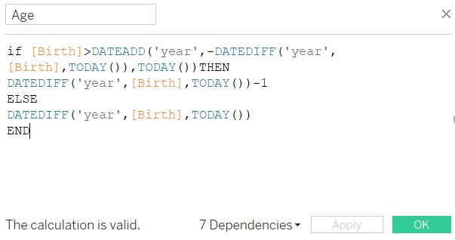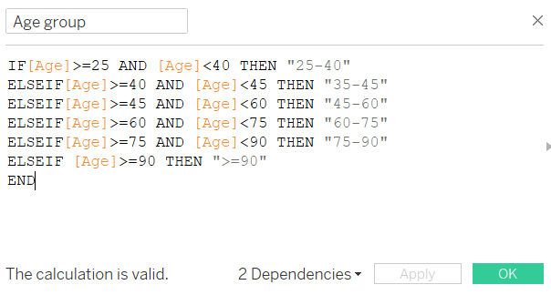The number of years/age computed as of 2022 will be based on the YOJ and birth variables and further the Age group field is created involves dimensions of ranges of age groups.

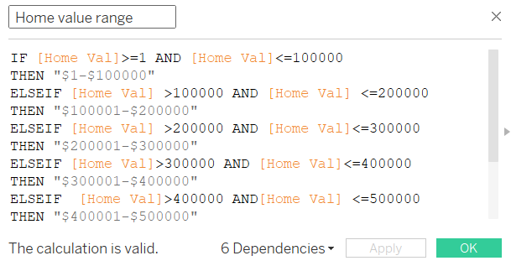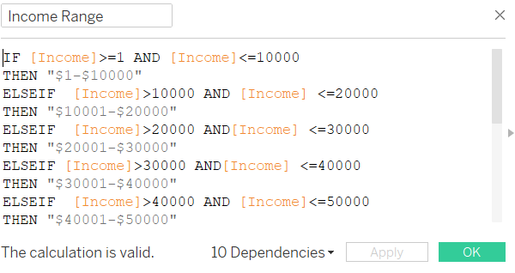Defining the ranges for Income and Home value fields.

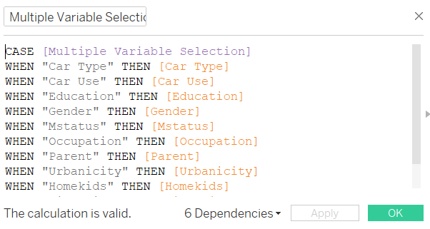Defining calculated field for Multiple Variable selection criteria parameter.

# Insights of Customer Demographics:

* Female customers are somewhat more numerous than male customers.
* Customers who are married account for around 60% of the total.
* High school is the most common level of education among customers, followed by a Bachelor's degree. The Ph.D. holders are at the bottom of the list.
* Customers with blue collar and clerical jobs make up the majority of the customers. Doctors' records have the least number of records.
* The majority of the customers are between 45 and 75 years old.
* The SUV is the most popular vehicle, while the panel truck is the least.
* Cars are mostly used for personal purposes.
* Majority of the customers are from urban area.
* The majority of customers have an annual income of more than $100,000. There are also records of customers with no income as well.
* Majority of the customers do not own a house.

# Insights of Customer Occupation Details:

* In both urban and rural regions, blue collar employment has the greatest impact on claims, while doctors have the least impact.
* Managerial, professional, and clerical occupations are also among the most commonly filed claims.
* The percentage of males and females filing claims is about equal, and we can observe that married people have more claims than unmarried people in all fields of occupations.

# Insights of Customer Education Details:

* Bachelors and high schoolers make up the majority of those who have filed claims.
* PhD holders with the least portion of top salaries are less likely to file an insurance claim, whereas people with a high school diploma who earn between $40K - $65K have the largest number of claims, accounting for around 60% of all claims.
* Urban areas have a substantial number of persons with a high school diploma and a bachelor's degree in the dataset. In terms of education, girls outnumber males.
* Female dominates each of the Income group irrespective of the educational background.

# Insights of Customer Travel time Details:

* The urban customers claims are more compared to the claims of rural customers.
* The travel time of pickup car type is comparatively more and has more claims.
* Customers with average travel time between 25-50 minutes are have highest claimers.

# Insights of Customer Income Distributions:

* It's clear that doctors have the greatest average income, while students and home makers have the lowest.
* Unmarried customers earn more comparatively. The average income is especially very high for customers in urban areas.
* Irrespective of the education background people prefer to use the vehicles for private purpose across all the income ranges.

# Insights of Customer Car Distributions:

* SUVs and minivans are quite popular among youthful automobile buyers.
* The Panel Truck is popular among commercial owners and has a very good Average Bluebook value.
* SUVs are preferred by females regardless of income, followed by Sports Cars.
* On the other hand, males prefer minivans, followed by pickup trucks.

# Insights of Car types on claims:

* When it comes to old claims, the SUV sector provides the most, followed by the Minivan.
* However, in terms of current claims, the pickup sector has seen a large increase in the number of claims, although the SUV still leads the claims.
* Customers who own SUVs, Minivans, and Pickup’s account for over 50% of all current and old claims.
* The average number of SUV claims is 1831, accounting for over 30% of all car claims.
* While private users have made a major contribution to the claims.
* When compared to the male, females have been high claim customers.

# Insights of Car use on claims:

* As we saw that majority of the customers purpose of car is for private use, accounting for around 52.44% for current claims and 63.67% for old claims.
* The claim frequency for private use is 3753 accounting to around 61%.
* Customer who use Car for Commercial use are more likely to Claim Insurance Amount.

# Insights of Education of customers on claims:

* PhD holders having least proportion with highest Salary are less prone to Claim for Insurance and High School qualification customers are the highest number of claims.
* Customers with High School, Bachelor’s education level account to around 66% and 62% approximately for current and old claims respectively.

# Insights of Gender on claims:

* Female customers have over 57% of current and older claim amounts.
* The claim frequency for females is 3343 and male frequency is 2695.

# Insights of Marital Status on Claims:

* Old claims outride the current claim amount.
* Around 55% of the married customers have accounted to old claims and 54% of non-married to current claim amount.
* The over-all frequency claims of married customers are more.

# Insights of Occupation on Claims:

* Customer's whose Occupation is doctors with the highest salary compare to others are less prone to claim the Insurance amount and Blue Collar are more likely to Claim Insurance Amount.
* Blue collar, Professional and Clerical occupation holder are among the highest claim accounting for around 67% of current claims and 57% of old claims.
* Among the claims sector almost 26% is accounted by blue collar job holder which is almost equal to half of the claims.

# Insights of Parental status on Claims:

* Customers who are non-parents claim around 83 % of claims.
* Customer who are not parent have significantly high claim frequency which is around five times more than the claim frequency of customers who are parents.

# Insights of Urbanicity on Claims:

* Customers using cars in urban areas are claiming over 95 % of the current claim amounts which is obvious considering higher density of vehicles in urban areas compared to rural areas.

# Insights of Home kids on claims:

* As the number of kids increases the tendency of the claims reduces.
* The families with no kids are the highest claim contributors as compared to the family with kid or a teenager that can drive.
* The claim frequency is around 65% of the customers with no kids.

# Insights of Kids drive on claims:

* The claim frequency and claim amount is accounting to around 85% where there are no kids or teenagers of customers who can drive
* When compared to a family with a child or a teenager who can drive, families without children are the biggest claim contributors.

# Insights of Income and Home value on claims:

* Customers earning less than $90,000 had a higher claim than those earning more.
* People who own a home for less than $300,000 are more likely to file a claim than those who own a more expensive property.

# Insights of Car age on claims:

* The latest car owners have high tendency to generate claims as compared to the older ones as the claims declined as the car tends to get older.
* We can see that the maximum claims are on the first year of the car.

# Insights of Customers age on claims:

* Although, the claim amounts have declined gradually but the people in the age of 50-75 years still are the highest claim contributors as compared to the 30–40-year-old or 85–90-year-old.

# Overall brief Insights:

1. Increase in education level results in a decrease in the claims. Bachelors and high schoolers make up the majority of claims
2. With a high number of non-home owners’ customers, we could assume that these customers are not natives of the urban city.
3. SUVs are a popular vehicle with a large number of claims, raising their risk profile.
4. Majority of the claims are is around 50, indication of which is an increased risk within close proximity of pensionable age.
5. Women had higher old claims than men
6. Claim amounts are high for vehicles used for commercial purposes
7. Exorbitant claims will be made on exclusive vehicles such as sports cars.
8. The higher rate of claims among individuals in the highest income band might be attributed to the pricey cars that those customers buy.
9. Increased frequency of claims from the same customers indicates a high level of risk.
10. Large frequency claims approximately after 10 years of car age.

# Business Recommendations:

1. Insurance for SUVs should be given at a premium price, whilst rates for Panel Trucks can be decreased or paired with special incentives for customers.
2. Insurance company can target Doctors as they tend to claim less than any other profession.
3. Discounts can also be given to clients based on their employment and age.
4. Considering private cars are valued higher than commercial vehicles, the price for their upkeep can be raised.
5. Customers who are not married or have children should be offered incentives or lower premium since their claim frequency is low.
6. Students and people with fewer than five years of job experience can be catered with some insurance plan policies.
7. Customers with fewer claims in the past should be offered incentives as well as enticing offers to purchase new insurance.
8. Insurance to boost the company's customer base, premiums might be reduced for new customers or advantages such as free car check-ups can be offered.
9. Certain discounts, such as "Good Grade" – merit-based insurance discount, and "Multiple Policy" – for customers with other insurance policies, might be provided in order to maintain existing customers and attract new ones.
10. People earning less than $60,000 have filed more claims, thus the present condition and age of their cars should be evaluated before they are offered insurance.
11. Cars that take longer to travel have more claims. As a result, before providing insurance, the distance travelled and the purpose should be considered.
12. Highly urban/urban locations should have their insurance amounts and terms appropriately examined because they have the most claims.
13. People who work in blue collar jobs are more likely to live in cities and have a long history of filing insurance claims. As a result, the insurance premium can be changed based on the cars they drive.
14. Because SUVs and minivans have a larger frequency of claims, these vehicles must undergo a necessary inspection before being insured.
15. Providing protection in case of an injury or accident
16. Coverage by a third party (in case of any injury or even demise)
17. Providing protection in case of natural disasters such as floods, earthquakes, landslides, and so forth.
18. Consider raising insurance prices for high-value cars.

# Additional Recommendations:

1. Establish a customer-centric services organisation to map and supply contextual services based on consumers' "particular requests."
2. Create a value-tree of his or her family, recommendations, friends, or any other related individuals so that the insurer may measure "overall demand" by understanding the experience in its entirety.
3. Providing a mix of experiences (human and artificial intelligence, physical and virtual, direct and agent-based).
4. Creating new advertising campaigns and promotional offerings in order to keep top clients while also attracting new ones.
5. In order to reduce danger, devalue the car according to market value as it becomes older.
6. Clients with a higher level of education, professionals, and customers with an income of more than $100,000 could help in building the business.
7. **Emphasize customer service and continual assistance:** Company should avoid selling each customer only one insurance at the lowest price and concentrating account sales, which increases client retention.
8. **Build an Insurance Partnership:** The consumer usually does not prefer to look for a new broker every year. Company should concentrate on developing long-term relationships with the clients and ensuring that both the client and our employees understand the significance of such a connection.
9. **Focus on target markets:**   Instead of enabling potential consumers to pick the company, the company should work on identifying and selecting personal and business customers to insure, results in brokerage.

# Link of the Tableau public: Please download and view the story board in presentation mode, since the views are adjusted accordingly.

<https://public.tableau.com/app/profile/pooja.kabadi8245/viz/DVTProject-CarInsuranceclaim-1/STORYBOARD-CARINSURANCECLAIM?publish=yes>